The esidoc base
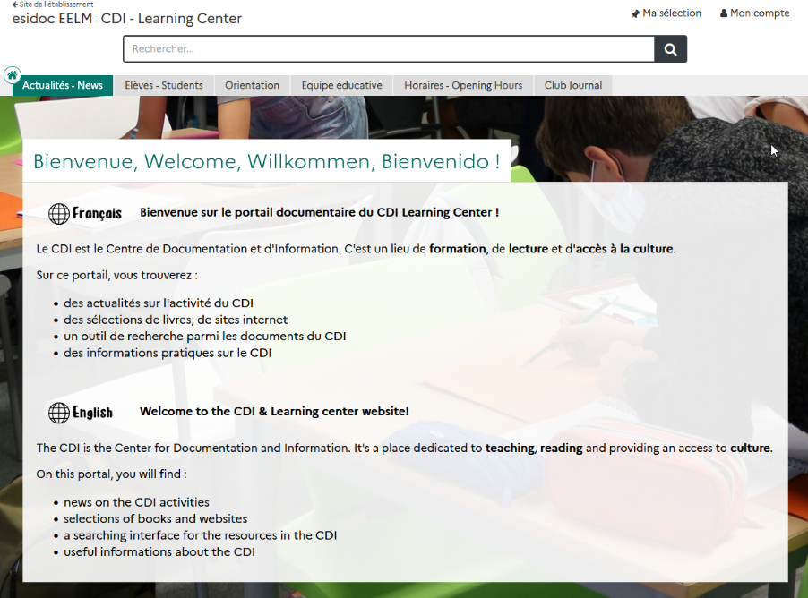
How do I access esidoc?
- From Pronote
- From the school website

Exercise
How many documentaries are there at the CDI? ……………………………………

What is the shelf mark of the book The Spectaculars? ……………………………………

Is Billy Summers book currently on loan? ..........................................

There is only one novel in German, what is his title? ……………………………………

The CDI subscribes to the news magazine I love English World. What is the number of the first issue that is available at the CDI?
……………………………………

Esidoc also references interesting websites. Find the one named : Egyptian Gods – The Complete List. What is the name of the Encyclopedia it’s in ?

…………………………………………………………………………………………………………………

