Name : ………………………….

**My CDI booklet**

CDI  = ……………………………………………………………………………………………………………

The CDI is an educational facility: it is a place where teachers can organise lesson sessions. When there are no lessons or activities, AND when Mrs Seyman is available, it is open to students.

**Students come to the CDI :**

- accompanied by a teacher as part of their work in the CDI

- as part of a session with the “teacher librarian”

- during free time if the CDI is not occupied by a class

- during recess or lunch break, if the CDI is open.

Before entering the library, I check whether it is occupied or not. I come for a whole period.

**I come to the CDI :**

- to do documentary research

- to work with CDI documents

- to read, borrow or return a CDI document

- to find out about career guidance and careers

**I must :**

- come quietly

- respect the school rules and the digital charter

- ask permission to use the computers

- keep things tidy: put the books away, put my chair back in its place

- respect others

**The CDI offers a range of documentary resources:**

|  |  |
| --- | --- |
| F | N F |
| N | Information on O |

These books are organised according to a classification plan.

**How do I find a book ?**

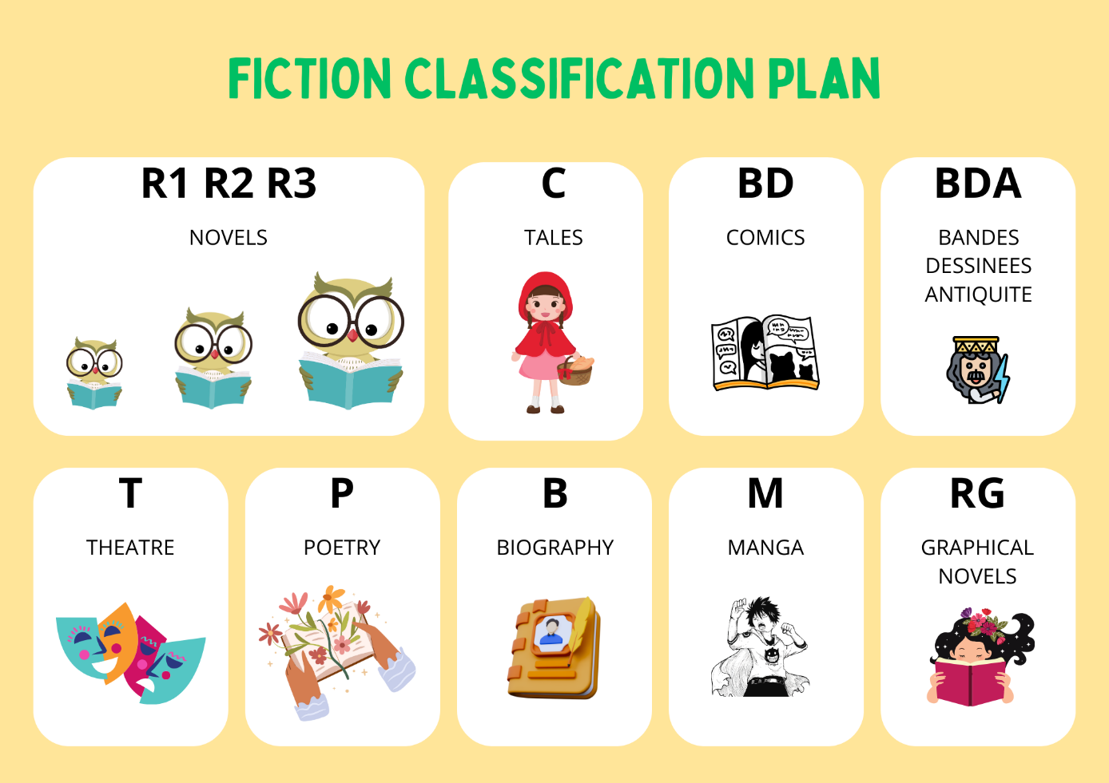

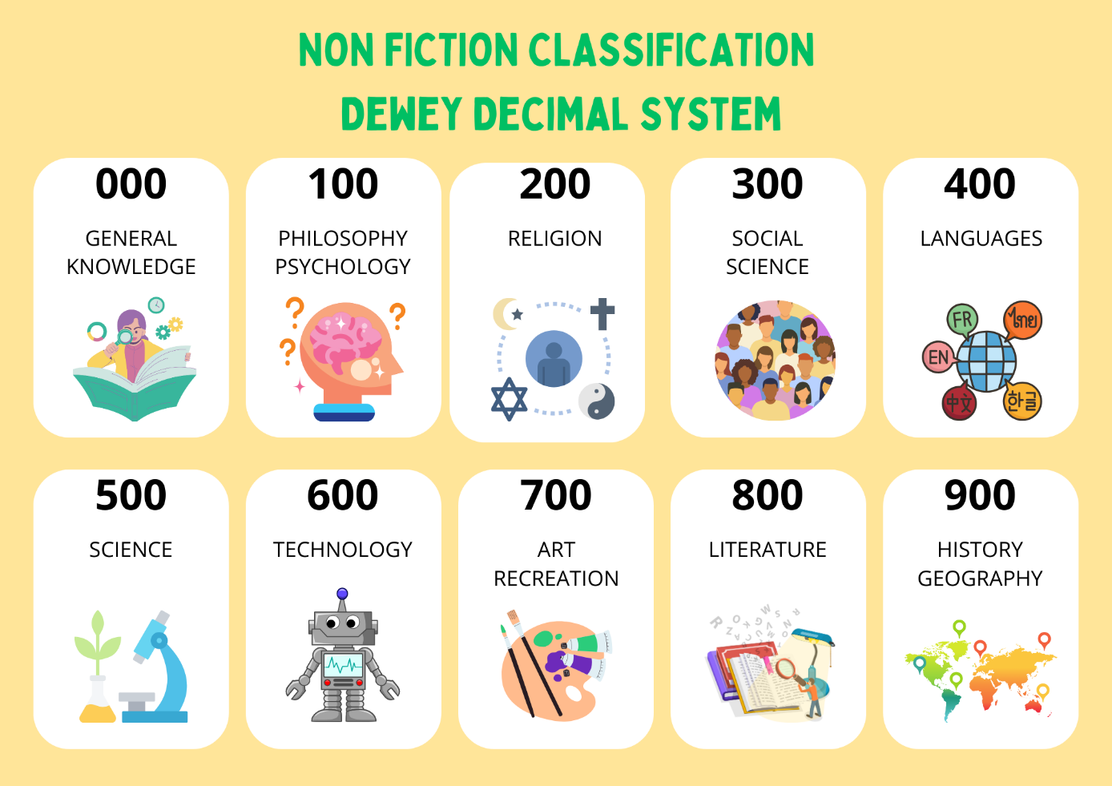

**Exercise**

|  |  |
| --- | --- |
| **Nature :**  **Title :**  **Author :**  **Language :** | **Shelf mark** |

|  |  |
| --- | --- |
| **Nature :**  **Title :**  **Author :**  **Language :** | **Shelf mark** |

|  |  |
| --- | --- |
| **Nature :**  **Title :**  **Author :**  **Language :** | **Shelf mark** |

**Practical exercises :**

Borrowing and returning a book

Searching for a book on esidoc

Checking your esidoc account from Pronote